**Test Cases for the Graphics Editor application**

* **Launch Application**
  + Test Case: Verify the application launches without errors.
  + Steps:
    - Run the Python script.
    - Check if the main window appears.
  + Expected Result: The application window opens successfully.
  + Failure Status: If the application crashes or fails to launch, note the error logs.

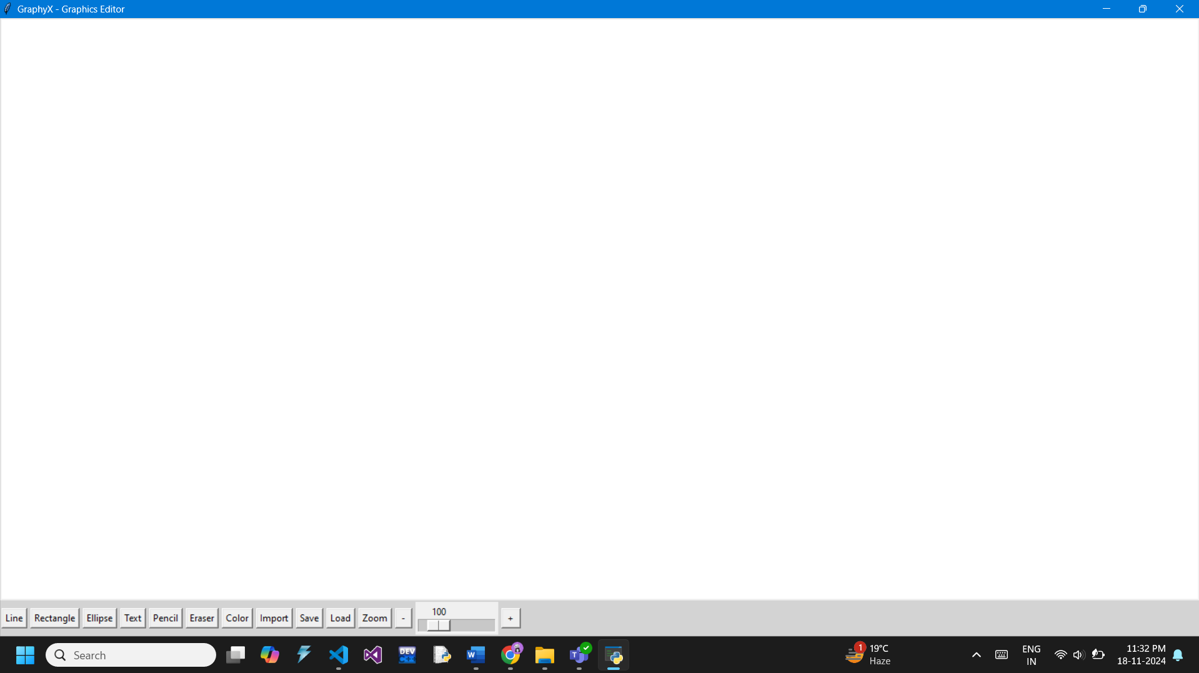

* + Test Result: Passed
* **Tool Selection**
  + Test Case: Verify that the tools (Line, Rectangle, Ellipse, etc.) can be selected.
  + Steps:
    - Click on each tool in the toolbar.
    - Check if the tool activates.
  + Expected Result: The cursor or behaviour changes appropriately for the selected tool.
  + Test Result: Passed
* **Drawing Tools**
  + Test Case: Test line, rectangle, and ellipse drawing.
  + Steps:
    - Select each tool.
    - Drag the mouse on the canvas to draw the corresponding shape.
  + Expected Result: The drawn shapes should match the selected tool.
  + Failure: If incorrect shapes appear or if they aren't drawn.

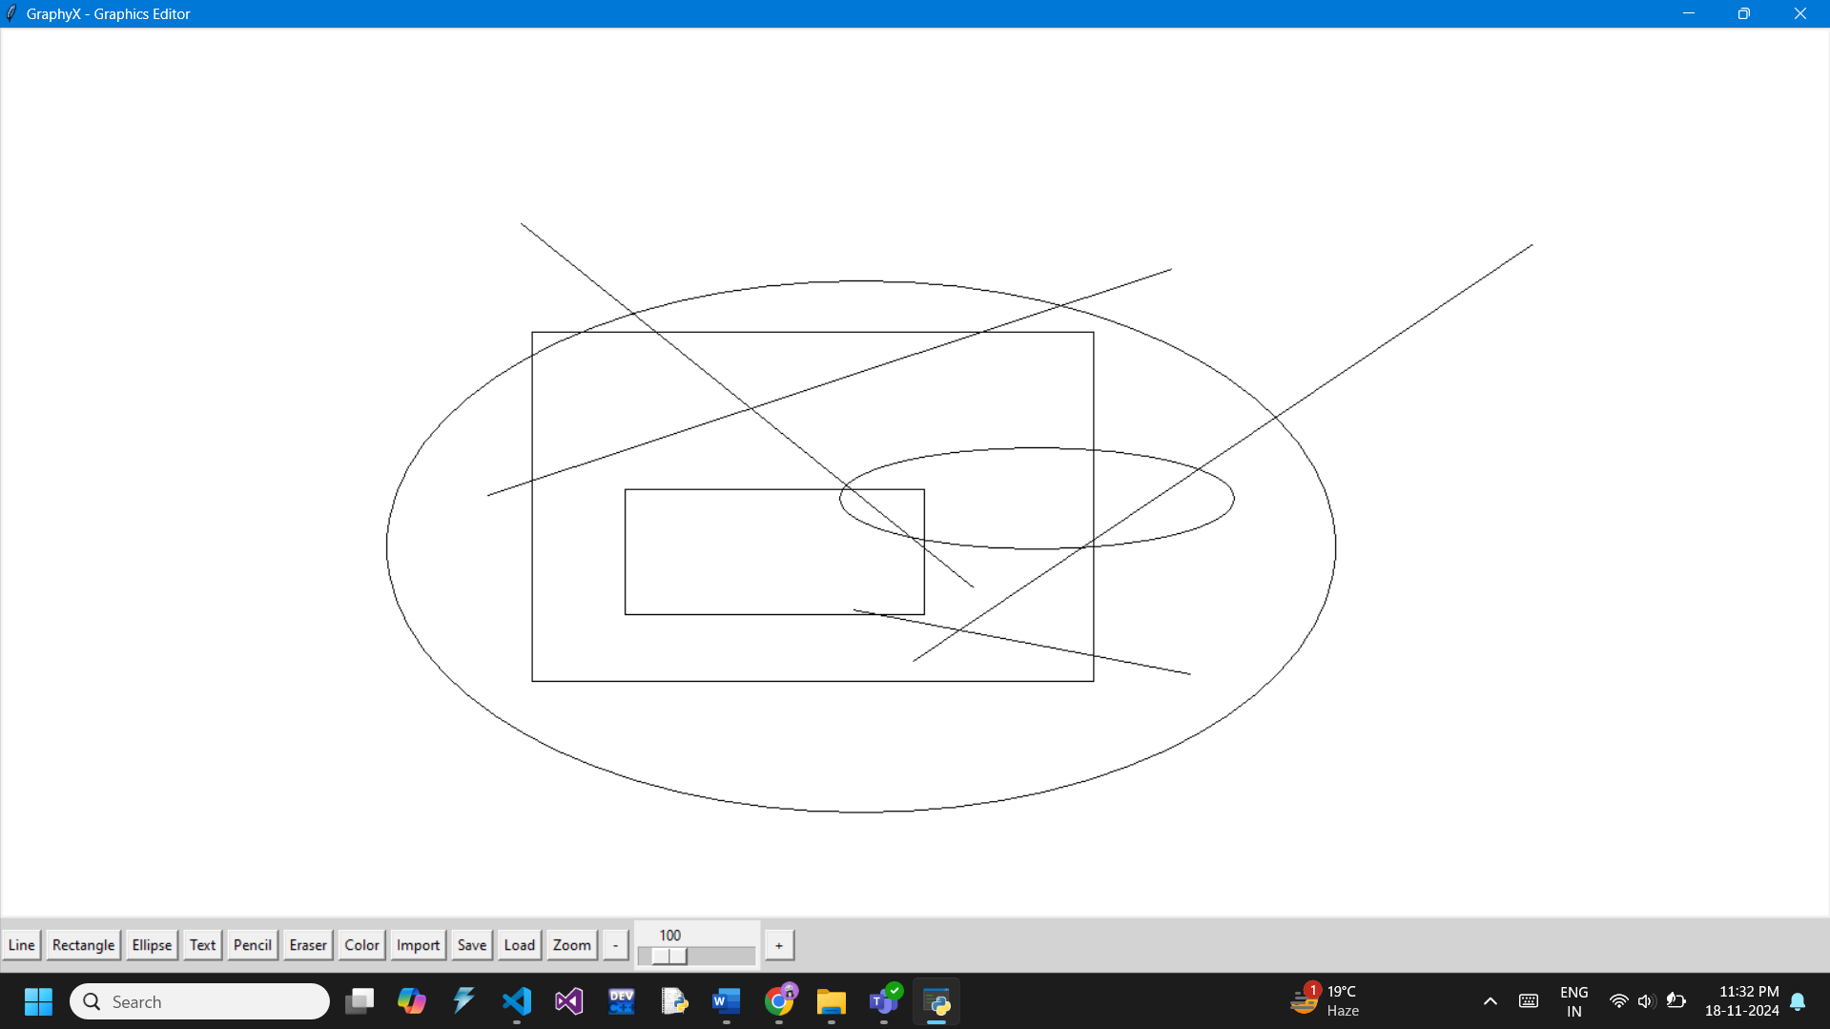

* + Test Result: Passed; We are able to successfully draw an Ellipse, Rectangle or a Line.
* **Text Tool**
  + Test Case: Verify the text tool functionality.
  + Steps:
    - Select the text tool.
    - Click on the canvas, input text in the dialog, and press Apply.
  + Expected Result: The entered text appears on the canvas.
  + Failure: Text does not appear or appears in the wrong format.

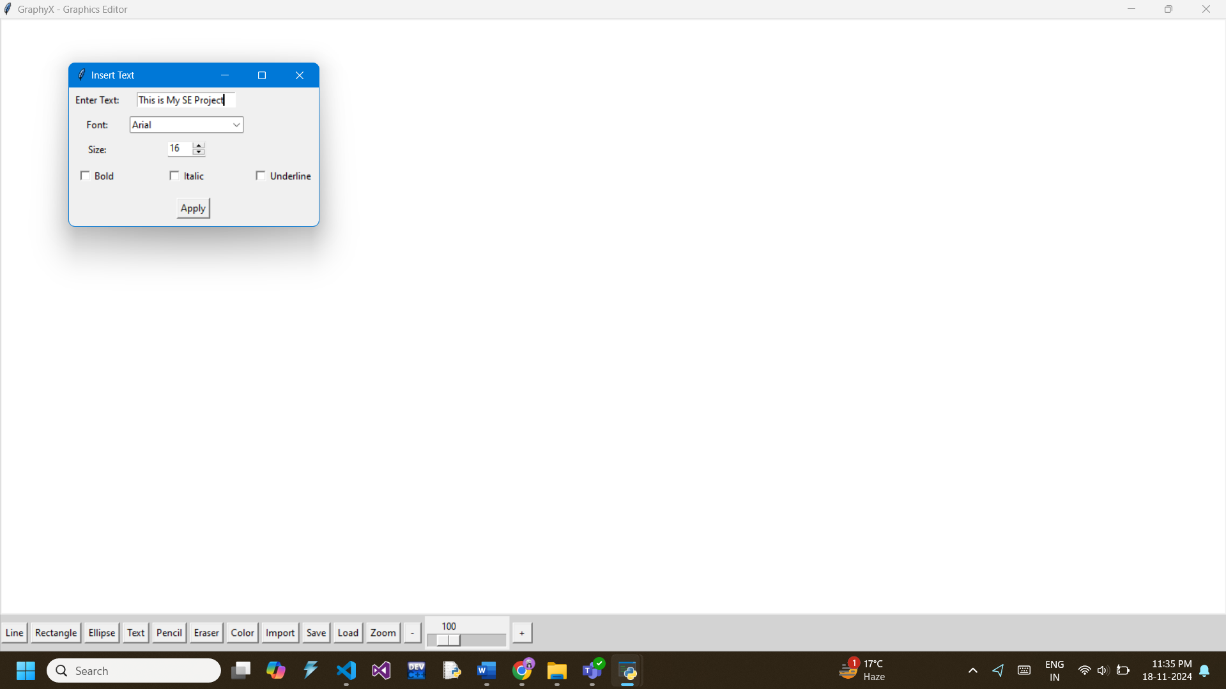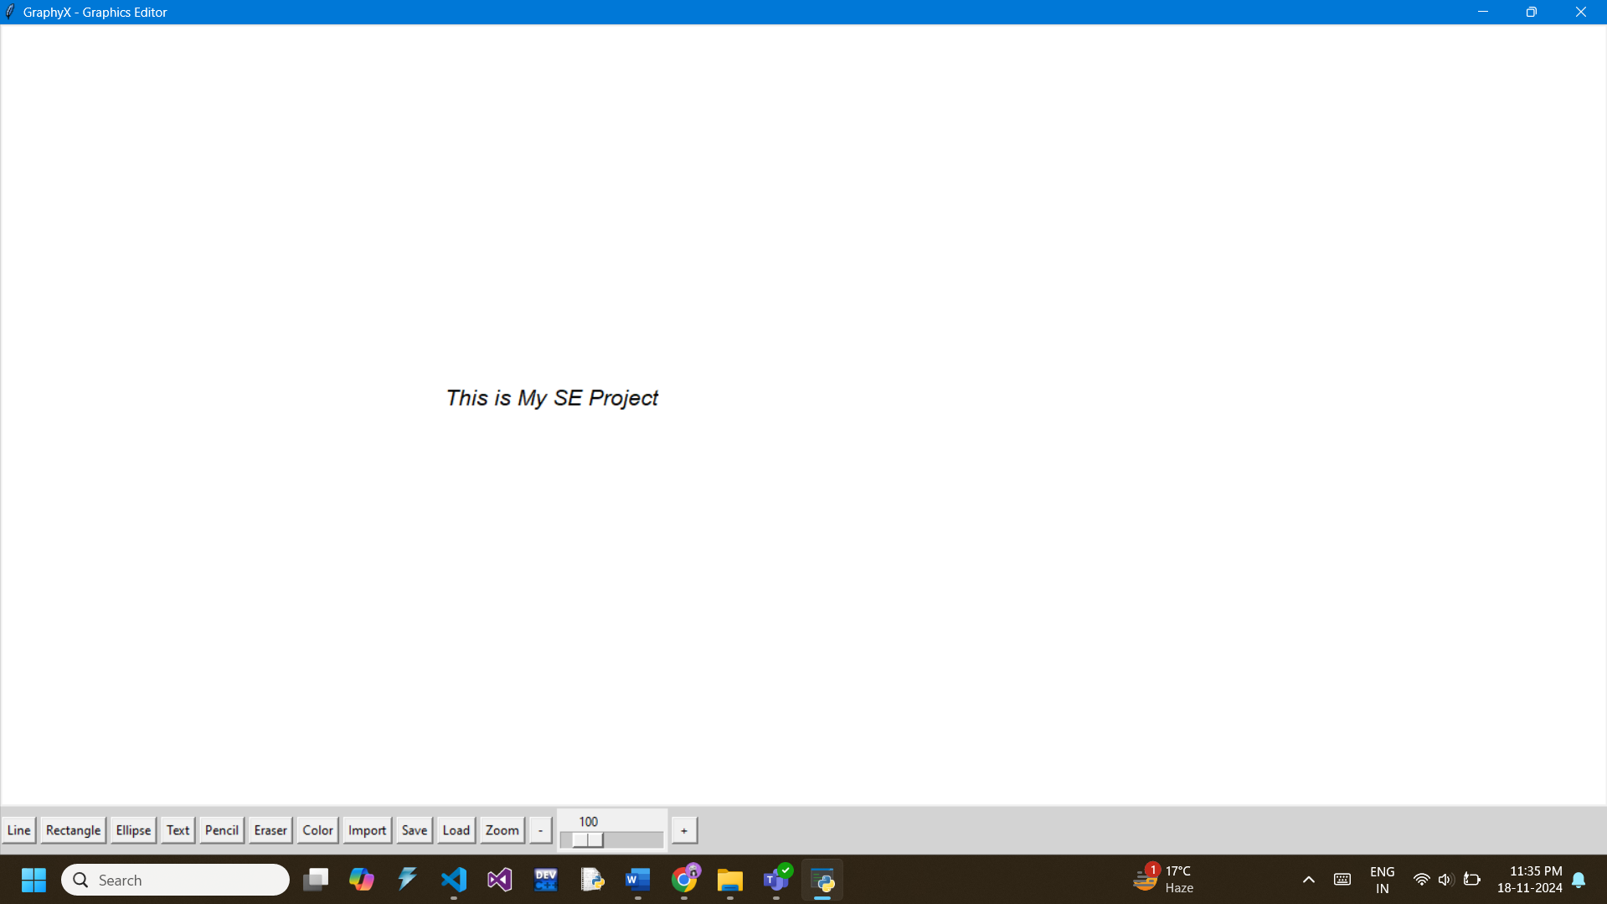

* + Test Result: Passed; We are able to insert a Text of our choice. Font, Size and other features can be altered by the user.
* **Colour Picker**
  + Test Case: Test the colour picker.
  + Steps:
    - Click on the "Colour" button.
    - Select a colour and draw a shape.
  + Expected Result: The shape is drawn in the selected colour.
  + Failure: The default colour or a different colour is used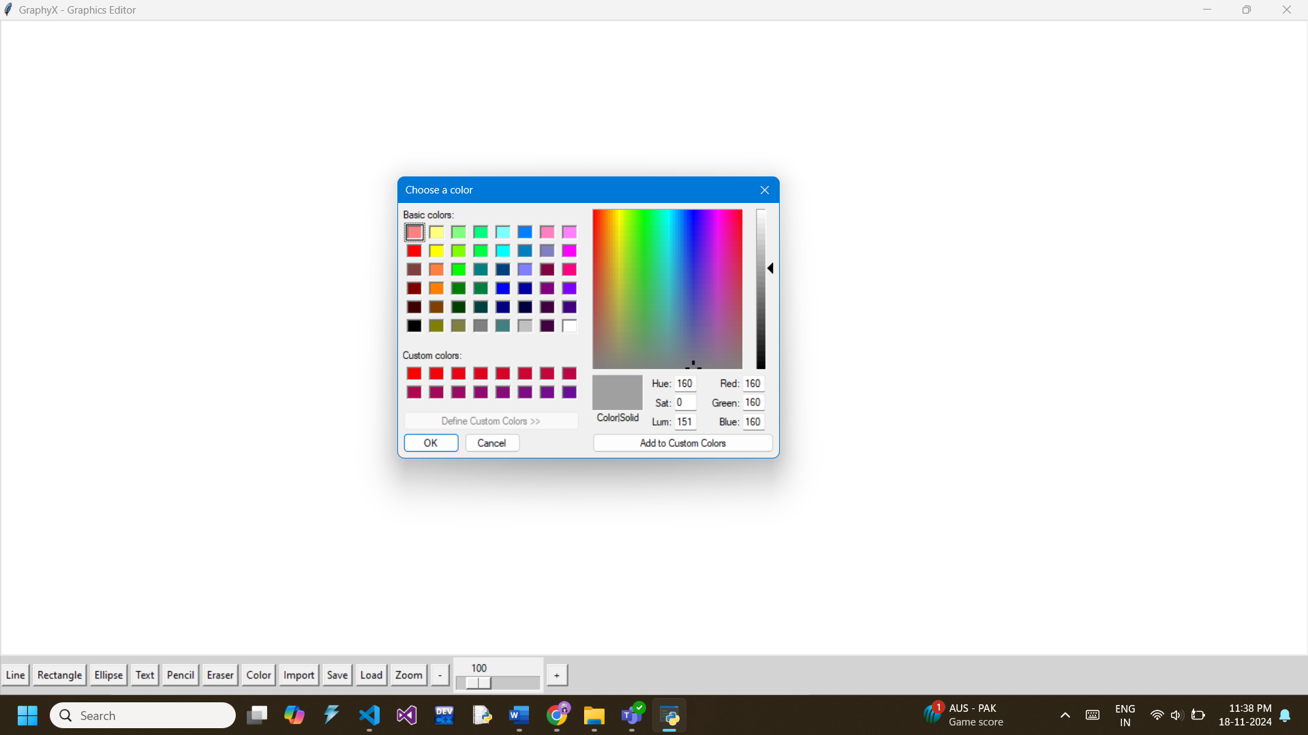
  + Test Result: Passed; A colour picker appears and we are able to draw shapes and write text of picked colour.
* **Pencil and Eraser**
  + Test Case: Verify pencil and eraser functionality.
  + Steps:
    - Select the pencil and draw freely.
    - Use the eraser to remove parts of the drawing.
  + Expected Result: Pencil draws freely; the eraser removes content.
  + Failure: Either tool does not behave as expected.

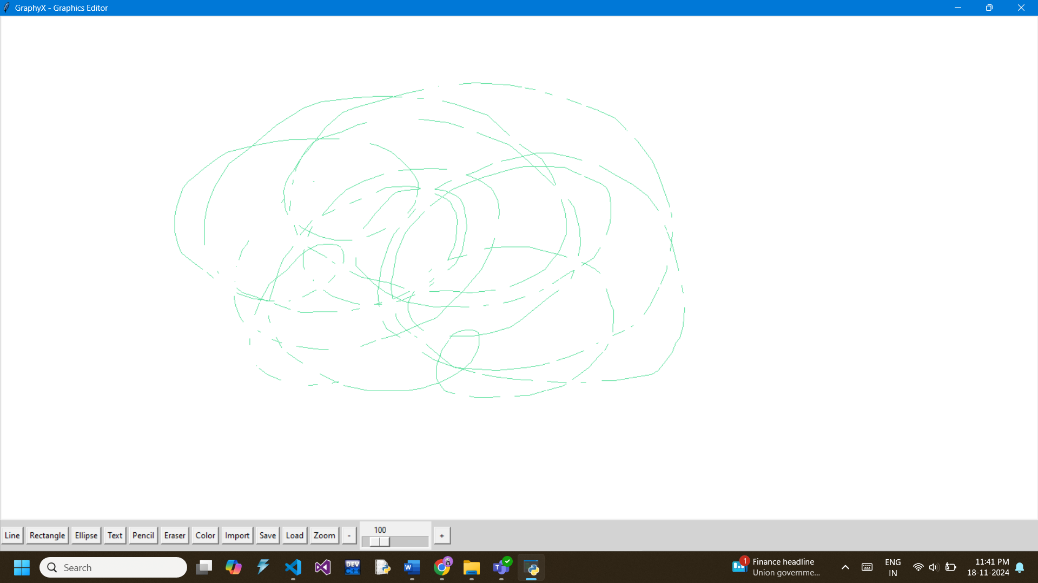

* + Test Result: Passed; We are able to free-hand draw using the Pencil tool and erase contents drawn on the canvas using the Eraser tool.
* **Import Image**
  + Test Case: Test importing an image.
  + Steps:
    - Click "Import" and select an image file.
    - Check if the image appears on the canvas.
  + Expected Result: The image loads successfully and is visible on the canvas.
  + Failure: Image does not load or crashes the application.

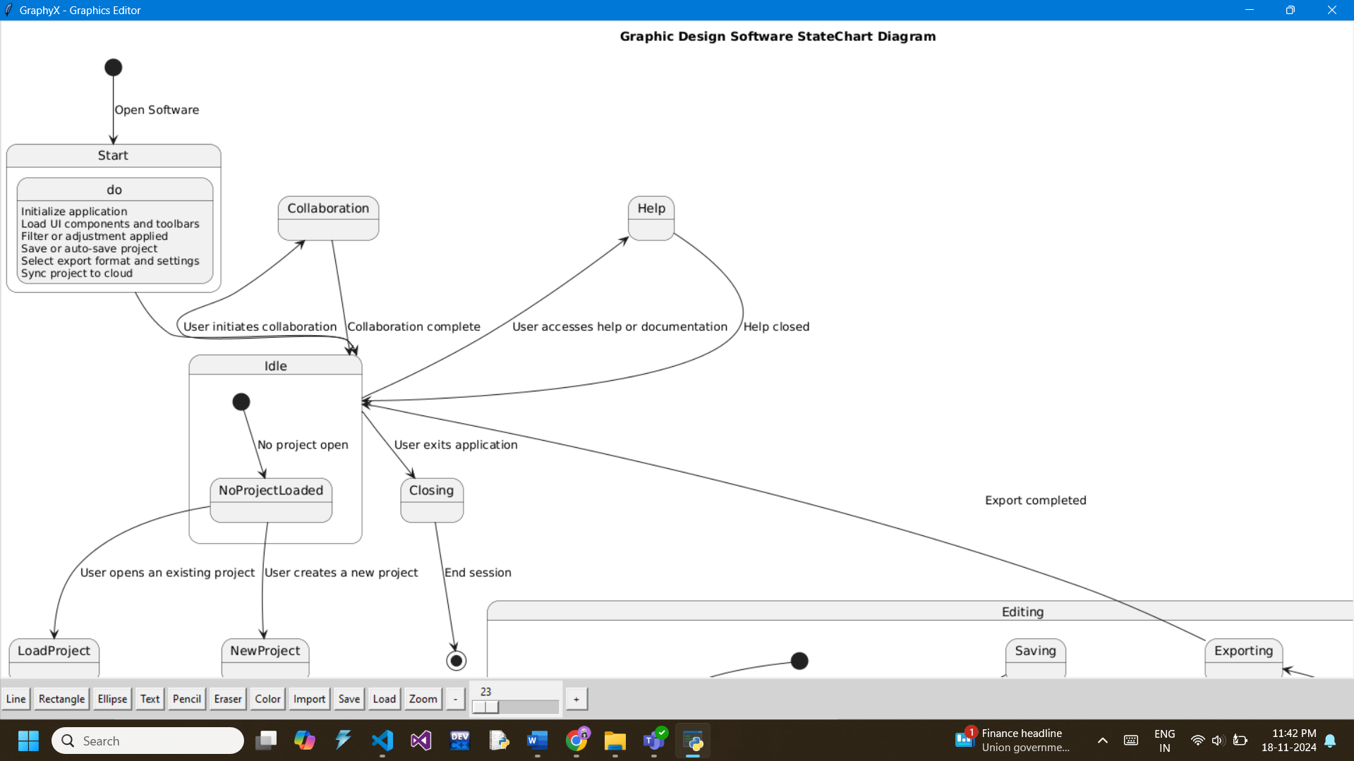

* + Test Result: Passed; We can successfully load a Bitmap image onto the canvas.
* **Save Canvas**
  + Test Case: Test saving the canvas to a file.
  + Steps:
    - Draw on the canvas.
    - Click "Save" and specify a file name.
    - Check if the file is saved and opens correctly.
  + Expected Result: The saved file matches the canvas content.
  + Failure: File does not save or content is incorrect.

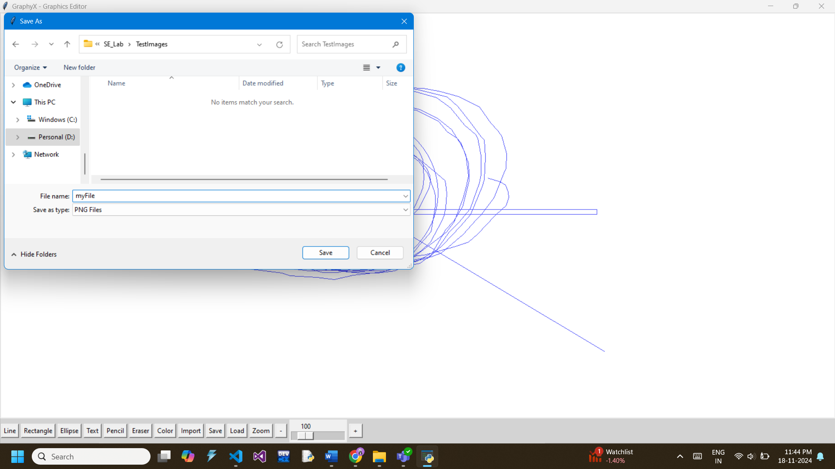

* + Test Result: Partially Passed; We are able to save the current Drawing as a .ps file but not as a .png or .jpg file like we would have liked.
* **Zoom In and Out**
  + Test Case: Verify zoom functionality.
  + Steps:
    - Use the zoom buttons and slider to adjust zoom levels.
    - Check if the canvas content scales correctly.
  + Expected Result: Content zooms in and out as expected.
  + Failure: Content does not scale or artifacts appear.
  + Test Result: Failed; The Zoom-in and Zoom-out Partially works.
* **Further Improvement Scopes**
  + The Zooming Feature is to be perfected.
  + The Panning Section has to be implemented.
  + Each component of our Painting has to be saved with separate Identity Numbers so as to be able to manipulate them after they have been created.
  + We should be able to copy shapes into clipboards to be used later.